**A close up of a person

Description generated with high confidence**

Welcome to Silverline Montessori

Cypress Towne Lake

Hello Silverline Families! March has come and gone, and we are very excited to share what we have done and what we plan to do. Spring break was so much fun. We had dress up days for every day during the week. The students had a blast coming to school in their pajamas, being a little tacky and dressing as their favorite characters. Our Second Annual Spring Picnic went very well. Thank you to all our families who were able to join us for lunch that day. We had a great PTA meeting and hope to have even more parents there next time. Our PTA is growing, and our school is benefitting from all of your suggestions and ideas. We are thankful for our parent involvement at Silverline.

In April, we have many exciting things happening. We will start off with the My 5 Senses theme. Each day the classes will be focusing on a different sense. During the “Week of the Young Child,” they will also have different themes every day. That will move us into the Easter Fun theme. During this week we will be hosting our annual Easter Egg Hunt and classroom parties. Please note: will be closed on Friday, March 19th for Good Friday. When we return on Monday, it will be Earth Day. Be sure to wear green this day! To end a wonderful April, we will focus on the Bugs and Butterflies theme. We are excited for what April has in store.

**Montessori Education**

Over the years, there have been many of influential Montessori educated people that have grown up to become some of the most well-known people in the United States. For example, Larry Page and Sergey Brin both had Montessori Education and they are the founders of Google. Jeff Bezos grew up to be the founder of Amazon after completing his Montessori. Jackie Kennedy, P. Diddy, Prince William, Prince Harry, Julia Child and Anne Frank all came from Montessori backgrounds. No doubt about it, we are educating the future leaders of America right here in our school.

**Featured Staff Member- Ms. Cassie Lopez**

This month’s featured staff member is a part of our wonderful Young Toddler classroom. Ms. Cassie Lopez has been such a wonderful asset to our school. She is hardworking and truly a team player. We love her ideas that she brings and the smiles she puts on faces. We are honored to have her a part of our Silverline family!

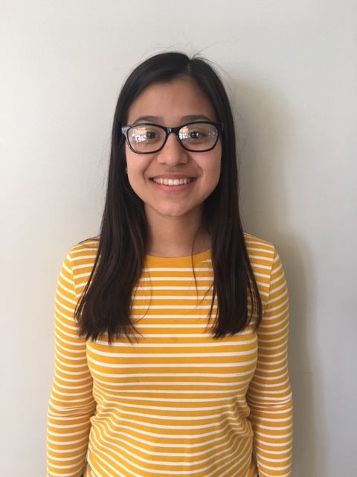

April 2019 Themes*:*

1. My 5 Senses
2. Week of the Young Child
3. Easter Fun
4. Earth Day
5. Bugs and Butterflies

Important Dates:

April 1st/2nd: Picture Day

April 18th: Easter Parties and Egg Hunt

April 19th: School Closed for Good Friday

April 22nd: Earth Day; Wear Green

Reminders:

* Drive slowly in the parking lot
* Check e-mails and KidReports daily for any updates
* Please be sure to label all of your child’s belongings

Quote of the Month:

“The best preparation for tomorrow is doing your best today.”

-H. Jackson Brown Jr

**18434 Cypress North Houston Rd. 281-373-1200**

**April 2019**

**Monthly Newsletter**

**FRIENDLY REMINDER**

In this section, remind families of anything new at your School (e.g., new annex, new playground equipment) or an on-going minor issue in your School (e.g., bringing sleeping bags back on Mondays).