.
January
Sun. | Mon. | Tue. | Wed. | Thu. | Fri. | Sat.
 | 31 | 1 | 2 | 3 | 4 | 5
Theme:  Texas Winter |  | New Year’s Day  SCHOOL CLOSED |  |  | 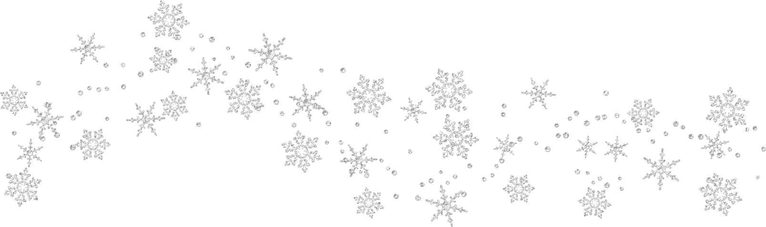
6 | 7 | 8 | 9 | 10 | 11 | 12
Theme:  Snow |  |  | Fork Painted Snowflakes |  |  | OPEN HOUSE  10:30-12:30
13 | 14 | 15 | 16 | 17 | 18 | 19
Theme:  Penguins | 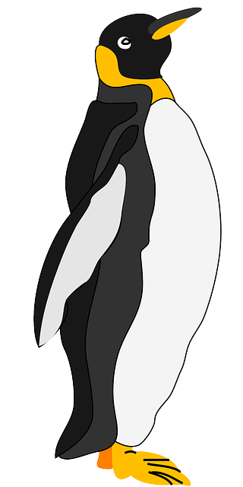 | Penguin Footprint Craft |  | PTA Meeting @6PM
20 | 21 | 22 | 23 | 24 | 25 | 26
Theme:  Winter Wear | Dr. Martin Luther King’s Birthday  SCHOOL CLOSED | Kinley’s Birthday | Ms. Elizabeth’s Birthday | Handprint on Mittens | 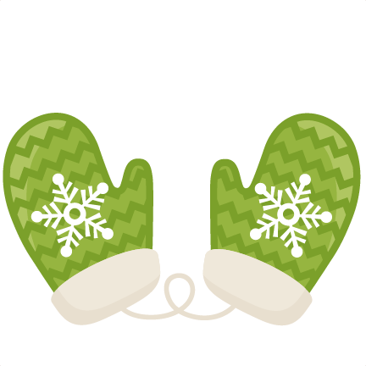 | Rushil’s Birthday
27 | 28 | 29 | 30 | 31
Theme:  Winter Animals |  | Marcus’ Birthday | Handprint Polar Bear | 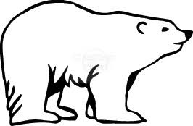
Notes | ARTIST OF THE MONTH:  DATES TO REMEMBER:  January 1st: School Closed  January 12th: Open House  January 17th: PTA Meeting 6 PM  January 21st: School Closed | - School Closures  - Parent Involvement Event  - School Wide Event  - Birthdays

