Sunday | Monday | Tuesday | Wednesday | Thursday | Friday | Saturday
 |  |  |  |  |  | 1
 | Composer of the month:
2 | 3 | 4 | 5 | 6 | 7 | 8
Theme: Music Around the World  Hanukkah Begins | 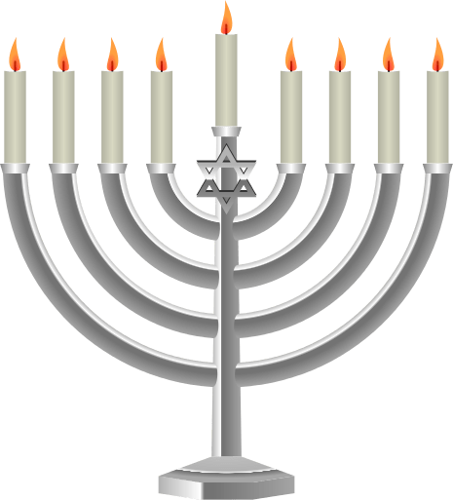 |  | Music from different countries |  | Leila’s Birthday | Rowan’s Birthday  Montessori Q&A
9 | 10 | 11 | 12 | 13 | 14 | 15
Theme:  Art Around the World | Hanukkah ends | Liam’s Birthday | Impressions |  | Holiday Program  @3 PM
16 | 17 | 18 | 19 | 20 | 21 | 22
Theme:  Winter Wonderland | Snowflakes |  | Parent’s night out  7PM-9PM |  | First day of Winter
23 | 24 | 25 | 26 | 27 | 28 | 29
Theme:  Holidays around the World | CLOSED | CLOSED | 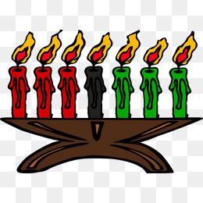  Kwanzaa begins |  | Cooper’s Birthday | Lucas’s Birthday
30 | 31 | 1 | 2 | 3 | 4 | 5
Lilian’s Birthday | New Year’s Eve | CLOSED  Kwanzaa ends
December
2018

Weekly Themes:  3rd-7th: Music Around the World  10th-14th: Art Around the World  17th-21st: Winter Wonderland  24th- 28th: Holidays Around the World |  | Dates to remember:  December 8th: Montessori Q&A  December 14th: Holiday Program  December 19th: Parents Night Out  December 24th-25th: Closed for Christmas |  |  | Color Code:  - School Closures/Holidays  - Parent Involvement Event  - School Wide Event  - Birthdays

