Silverline Montessori
Snack Menu
November 2018
 | Monday | Tuesday | Wednesday | Thursday | Friday
WEEK 1  November  1st – 2nd |  |  |  | Morning Snack  Flavored Yogurt  Blueberries  Water  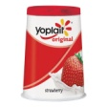  Afternoon Snack  Banana Slice with Orange Juice  String Cheese  Water | Morning Snack  Hummus  Sliced Carrots  Water  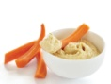  Afternoon Snack  Fruit Juice  Cinnamon Wheat Toast  Water
WEEK 2  November  5th – 9th | Morning Snack  Milk  Oatmeal Raisin Cookie  Water  Afternoon Snack  Peach Diced  Flavored Yogurt  Water  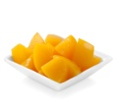 | Morning Snack  Milk  Hot Cinnamon Apples  Water  Afternoon Snack  Orange Segments  Ritz Crackers  Water  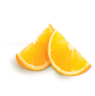 | Morning Snack  Tuna Salad On Lettuce  Wheatsworth Crackers  Water  Afternoon Snack  Apple Slices  Sun Butter Sandwich  Water  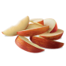 | Morning Snack  Edamame  Fruit Juice  Water  Afternoon Snack  Vegetable Slices  Wheatsworth Crackers  Ranch Dip  Water  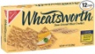 | Morning Snack  Milk  Rice Pudding  Water  Afternoon Snack  Fruit Cup  Goldfish Crackers  Water  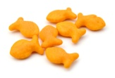
WEEK 3  November  12th – 16th | Morning Snack  Wheat Tortillas  Refried Beans  Water  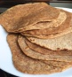  Afternoon Snack  Sun butter Sandwich  Water | Morning Snack  Cottage Cheese  Diced Melon  Water  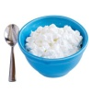  Afternoon Snack  Cucumber Slices  String Cheese  Water | Morning Snack  Celery Stick  Sun Butter  Raisins  Water  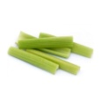  Afternoon Snack  Goldfish Crackers  Banana Slices  Water | Morning Snack  Roasted Turkey  Wheatsworth Crackers  Water  Afternoon Snack  Fruit Juice  Flavored Yogurt  Water | Morning Snack  Sliced Carrots  Hummus  Water  Afternoon Snack  Ritz Crackers  Orange Segments  Water
WEEK 4  November  19th – 23rd | Morning Snack  Flavored Yogurt  Sliced Strawberries  Water  Afternoon Snack  Vegetable Slices  String Cheese  Water  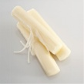 | Morning Snack  Milk  Granola Bar  Water  Afternoon Snack  Wheatsworth Crackers  Diced Melon  Water | Morning Snack  Pretzels  Sun Butter  Water  Afternoon Snack  Fruit Juice  Cheeze Itz  Water  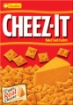 | Closed in Observation of Thanksgiving | Closed in Observation of Thanksgiving
WEEK 5  November  26th – 30th | Morning Snack  Granola Bar  Fruit Juice  Water  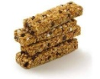  Afternoon Snack  Vegetable Slices  String Cheese  Water | Morning Snack  Yogurt Dip  Sliced Carrots  Water  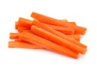  Afternoon Snack  Fruit Juice  Flavored Yogurt  Water | Morning Snack  Pretzels  Cheese Slice  Water  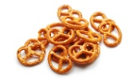  Afternoon Snack  Fresh Vegetables  Yogurt Dip  Water | Morning Snack  Celery Stick  Sun Butter  Water  Afternoon Snack  Apple Sauce  Goldfish Crackers  Water | Morning Snack  Zucchini Bread  Milk  Water  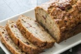  Afternoon Snack  Grape Tomato  Rice Chex  Water

