Silverline Montessori
July 2018 Snack Menu

Monday | Tuesday | Wednesday | Thursday | Friday
2  Morning Snack  Chex Mix, Water or Milk  Afternoon Snack  Wheat Roll or Bread, Chicken Salad  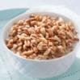  Water | 3  Morning Snack  Pretzels, Sun butter & Water  Afternoon Snack  Cheez It’s & Water  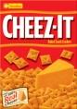 | 4  Morning Snack  Granola Bar, Fruit Juice  Afternoon Snack  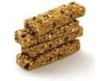  Vegetable Slices, String Cheese, Water | 5  Morning Snack  Hummus, Sliced Carrots & Water  Afternoon Snack  Rice Chex, Strawberries & Milk  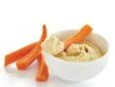 | 6  Morning Snack  Apples with Cheese &  Water  Afternoon Snack  Orange Segments  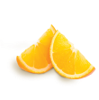  Ritz Crackers  Water
9  Morning Snack  Chicken Salad  Wheats worth Crackers & Water  Afternoon Snack  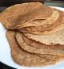  Sun Butter Sandwich  Water | 10  Morning Snack  Cottage Cheese  Diced Melon  Water  Afternoon Snack  Cucumber Slices  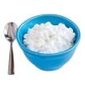  String Cheese  Water | 11  Morning Sack  Celery Stick, Sun Butter  Juice  Afternoon Snack  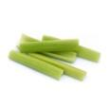  Goldfish Crackers, Banana Slices  Water | 12  Morning Snack  Flavored Yogurt  Sliced Strawberries & Water  Afternoon Snack  Vegetable Slices  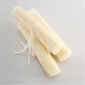  String Cheese  Water | 13  Morning Snack  Granola Bar, Milk & Water  Afternoon Snack  Wheats worth Crackers  Diced Melon & Water  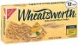
16  Morning Snack  Hummus, Sliced Carrots & Water  Afternoon Snack  Rice Chex, Strawberries  Milk | 17  Morning Snack  Yogurt Dip, Sliced Carrots & Water  Afternoon Snack  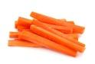  Cottage Cheese, Fruit Slices & Water | 18  Morning Snack  Granola Bar, Fruit Juice  Afternoon Snack  Vegetable Slices, String Cheese, Water | 19  Morning Snack  Cottage Cheese Wheats worth Crackers, Water  Afternoon Snack  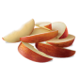  Apple Slices, Sun Butter Sandwich & Water | 20  Morning Snack  Chex Mix, Water or Milk  Afternoon Snack  Wheat Roll or Bread, Chicken Salad  Water
23  Morning Snack  Pretzels, Cheese Slice  Water  Afternoon Snack  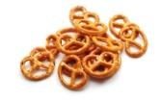  Fresh Vegetables, Yogurt Dip & Water | 24  Morning Snack  Flavored Yogurt, Blueberries & Water  Afternoon Snack  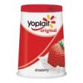  Cherry Tomatoes, Wheats worth Crackers & Milk | 25  Morning Snack  Chex Mix & Water  Afternoon Snack  Goldfish Crackers,  Fruit & Milk  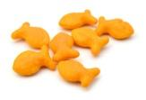 | 26  Morning Snack  Cottage Cheese  Melon, & Water  Afternoon Snack  Cucumber Slices  String Cheese & Water | 27  Morning Snack  Granola Bar, Milk & Water  Afternoon Snack  Wheats worth Crackers  Diced Melon & Water
30  Morning Snack  Pretzels, Cheese Sticks, & Water  Afternoon Snack  Celery Stick, Sun Butter & Water | 31  Morning Snack  Yogurt Dip, Sliced Carrots & Water  Afternoon Snack  Cottage Cheese, Fruit Slices & Water

