**A close up of a person

Description generated with high confidence** 

**Education and Peace**

As Montessori developed her theory and practice, she came to believe that education had a role to play in the development of world peace. She felt that children allowed to develop according to their inner laws of development would give rise to a more peaceful and enduring civilization. From the 1930s to the end of her life, she gave several lectures on this subject. She received a total of six nominations for the [Nobel Peace Prize](https://en.wikipedia.org/wiki/Nobel_Peace_Prize) in a three-year period. Elementary Montessori peace curriculum starts with Five Great Lessons that give a big picture of the world and life. They are educational stories that also spark the imagination of the students.

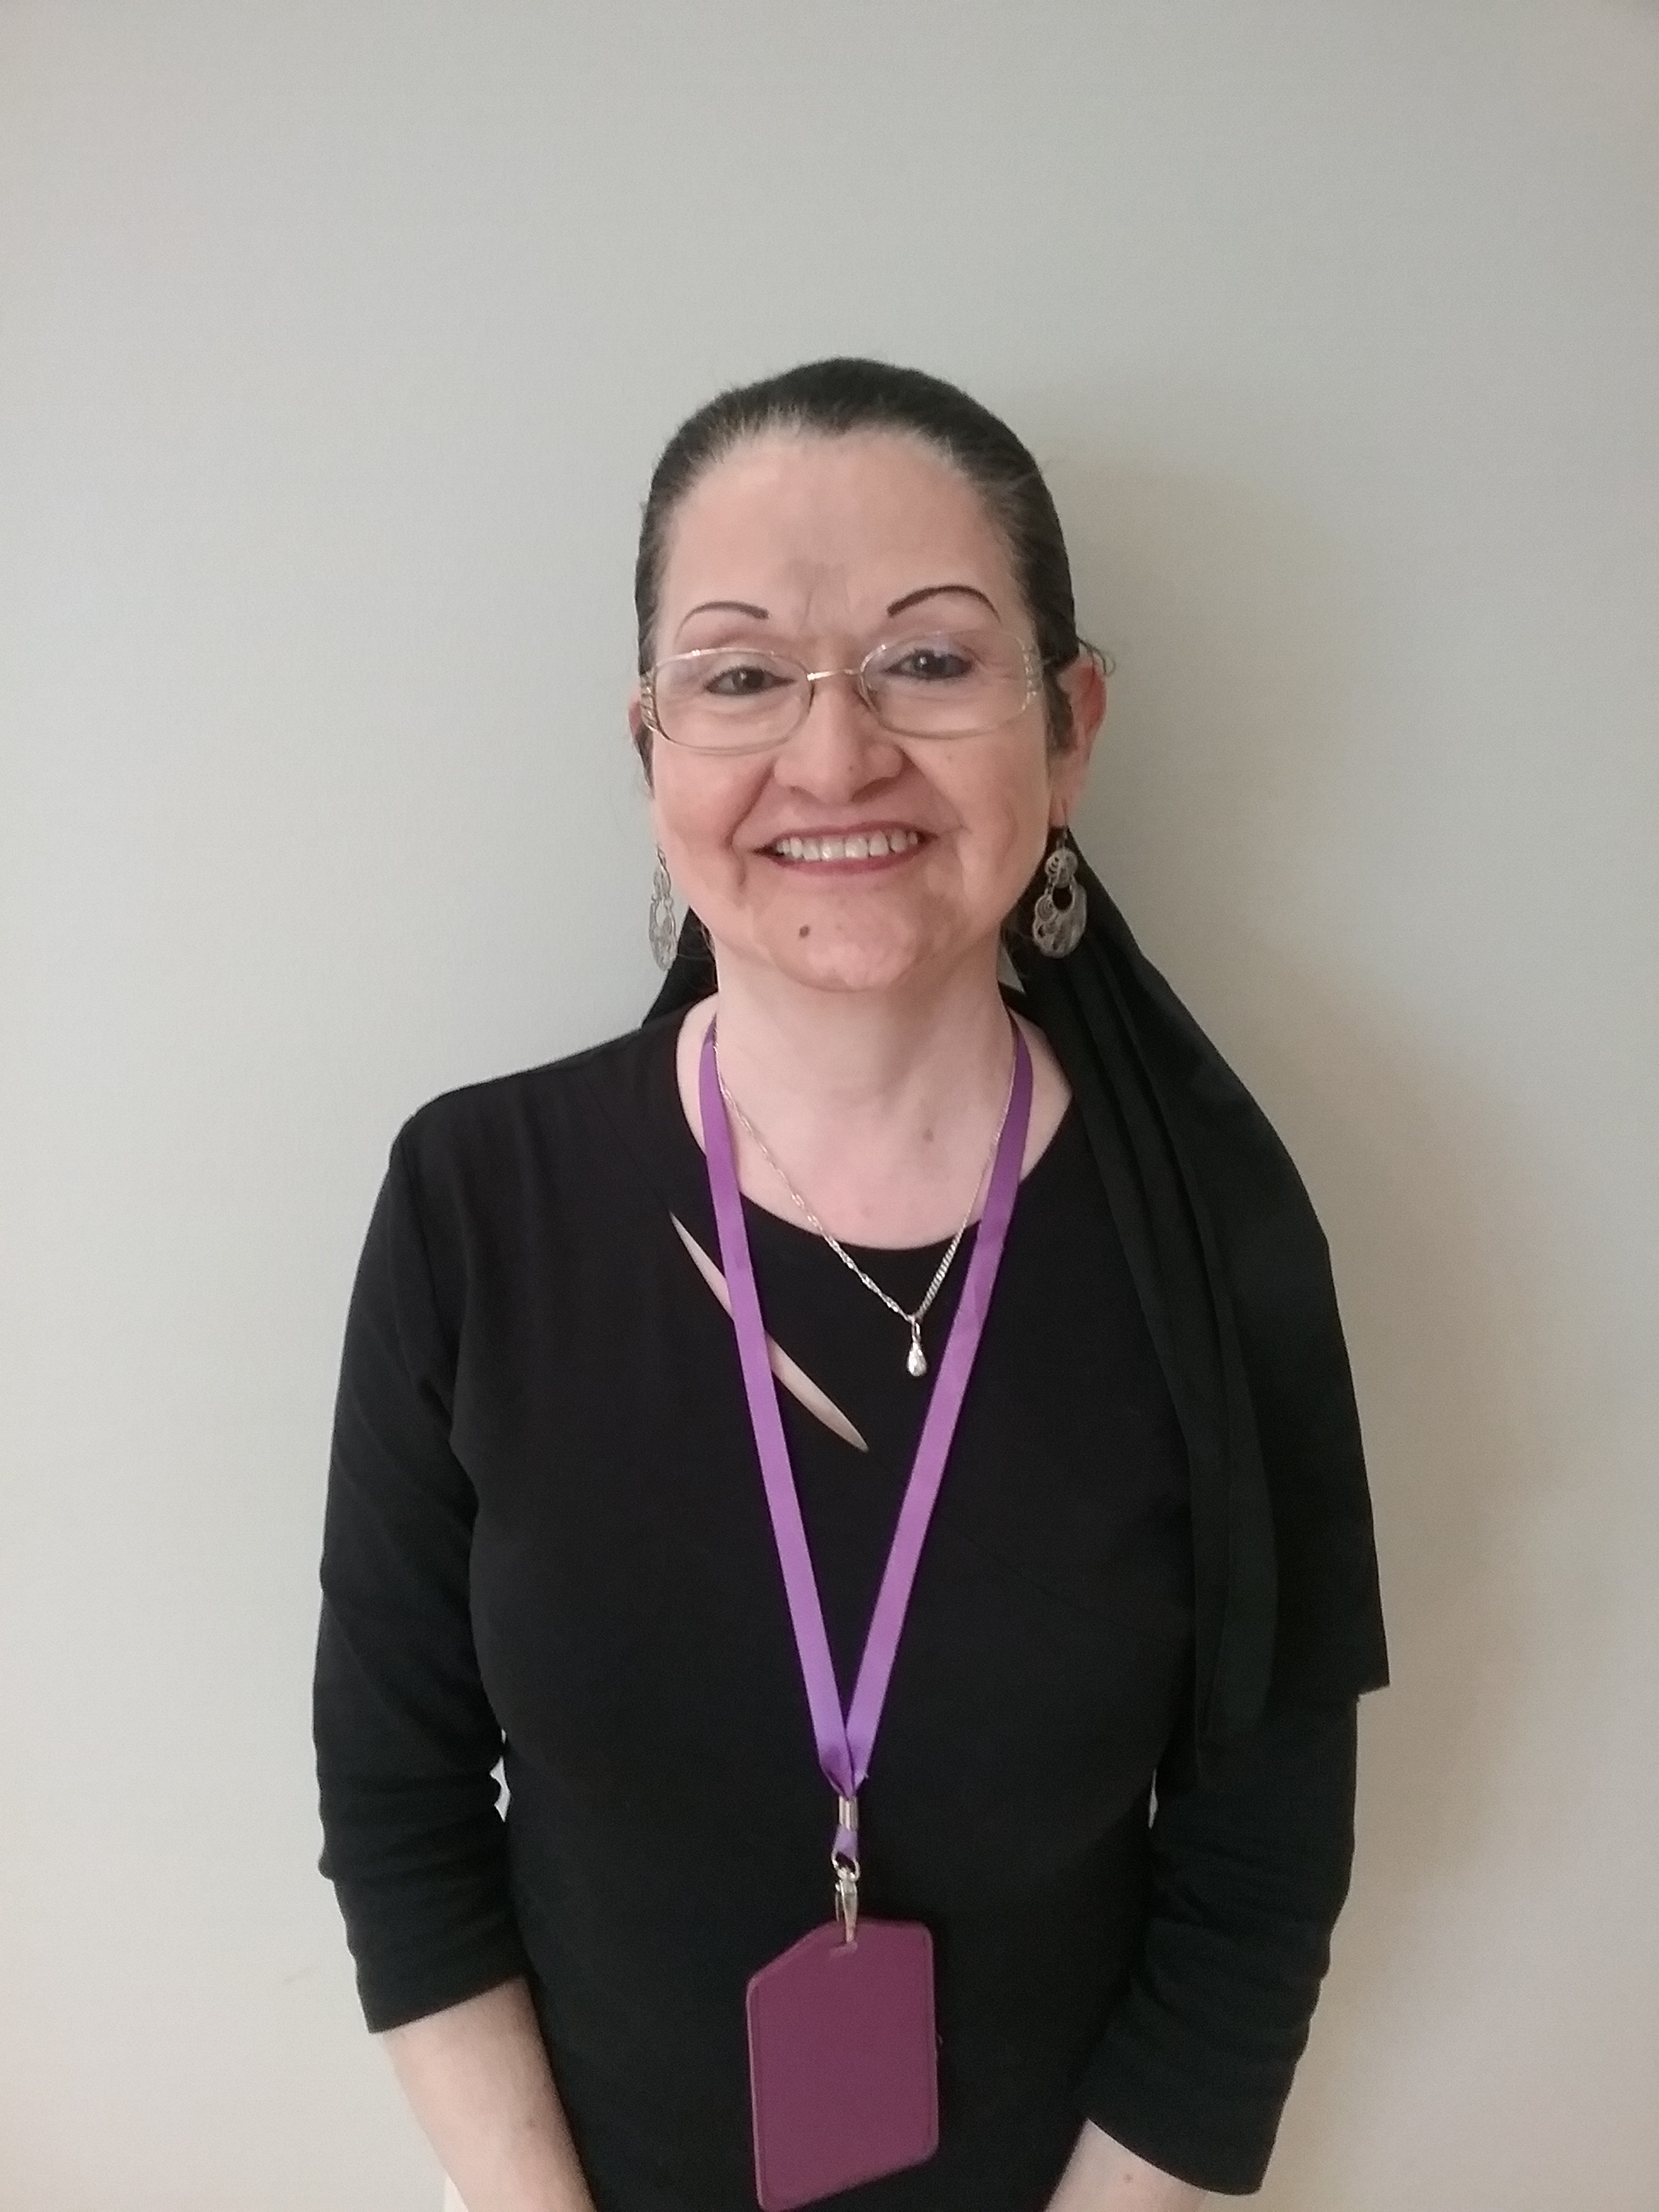

**Featured Staff Member- Dora**

Ms. Dora is our Infant 2 teacher! She has her CDA and over 22 years of experience working with infants. She works so hard and is always willing to lend a helping hand. She brightens up everyone’s day and makes all her babies feel at home. She is a wonderful asset to our team here at Silverline Montessori and we couldn’t be happier!

**Welcome to Silverline Montessori- Cypress**

The month of May was amazing! We had many different events planned that were total successes! In the days leading up to Cinco de Mayo, the students celebrated by creating different crafts representing the holiday. They made piñatas, ponchos and even maracas! They had a blast! Then it was teacher appreciation week, and on behalf of all our teachers and staff we wanted to say thank you to all our wonderful parents who gave gifts and tokens of appreciation! That Friday, we had the First Annual Mother’s Day Tea. We had a great turnout, and many moms came to fellowship and be honored. Parent Teacher conferences were also a big success! It is a joy to see our parents involved in their children’s education! We hope that you all enjoyed your long Memorial Day weekend and hope that you spent it with friends and family! We want to say congratulations to our first Pre-K graduation class of 2018!

We are excited to spend our first summer with our Silverline families, and have exciting events planned! Each week will be different themes and will have corresponding activities. We will have a Veterinarian here on June 6th to kick off our summer theme of Community Helpers. There will be an art exhibit that will showcase the students’ impressions of famous artwork. On the 15th we will be hosting Donuts with Dad in celebration of Father’s Day. There will be seashells hidden all around the school during the Under the Sea theme. If your child finds one, they can take it home! In the week with the Spanish theme, they will have longer Spanish lessons during line time.

The 21st marks the official first day of Summer and every Friday we will have Splash Day!

***June 2018 Themes:***

1. ***Community Helpers***
2. ***I am an Artist***
3. ***Under the Sea***
4. ***Spanish***

**UPCOMING EVENTS**

**EVERY FRIDAY IN JUNE IS SPLASH DAY!**

**June 5th: Veterinarian Visit**

**June 15th: Donuts with Dad**

**June 15th: Art Exhibit**



**Quote of the Month:**

**“Any man can be a father. But it takes a special person to be a DAD.”**



**D**



**Monthly Newsletter**

**June 2018**

**18434 Cypress North Houston Rd. 281-373-1200**

**FRIENDLY REMINDER**

In this section, remind families of anything new at your School (e.g., new annex, new playground equipment) or an on-going minor issue in your School (e.g., bringing sleeping bags back on Mondays).