##### 

# Silverline Montessori School News SLM_NewLogo1 copy-1.jpg May 2018

**2505 county Rd 89 Pearland, Texas 77584 281-997-3700**

**Important Events**

**May 4th –Cinco De Mayo**

**May 11th -Muffins for Mom 7:00-8:30 a.m.**

**May 30th -Kindergarten Graduation**

**May 28th -School Closed for Memorial Day**

**May 31st - Last Day of School**



 **Muffins for Mom**

**Muffins for Mom has been scheduled for May 11th from 7:00-8:30 a.m. Please stop by and have muffins, coffee and juice with your child in celebration of Mother’s Day.**



**Kindergarten Graduation**

This years' kindergarten graduation will be held on Wednesday, May 30, 2018 at the Silverlake Church at 6:00pm and is supported by the SLMPA (Silverline Montessori Parents Association).

**j0190799**

**End of Year Party**

Our End of the Year Party will be held on May 31st. We will have pizza, chicken nuggets, chips and dips, cookies, fruit and cheese trays and juice. Please sign up if you would like to bring something. A sign-up sheet will be posted outside your child’s classroom.

*j0429969***Sizzling Summer**

Fun! Fun! Fun! Our summer program is filled with field trips to Museums, Kemah, Skyzone, Downtown Aquarium, Moody Gardens and much, much more. We will also Science, Art, fun filled Splash days in our water park on the back play ground as well as math and language enrichment. Please pick up a summer registration packet at the front if you would like to join our summer program.

Culture and Science for May

MCj03830940000[1]

1. Living in a Healthful Place
2. 7 Continents
3. 4 Oceans
4. Ocean Life
5. Dinosaur
6. Endangered Species
7. Community Workers
8. Energy and Forces (Magnets)



We will celebrate Cinco De Mayo on May 4th . If you would like to bring a snack for your child’s class for Cinco De Mayo please let their teacher know (ex. Mini tacos, chips and dips. Quesadillas).

**The Montessori Corner**

# 

# **A Brief Overview of Elementary Montessori**

Montessori Elementary is a program that grows out of respect for the mind of a rapidly developing child. No longer content to have physical independence (achieved in the 3-6 age class), the child now strives for intellectual independence. This is a time of insatiable curiosity and excitement for learning.

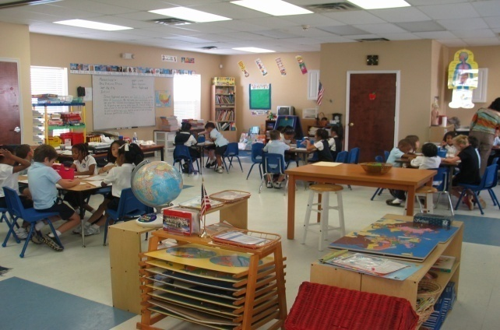

## The world as a classroom

Children in the 6-12 age group are starting to realize that the world is an enormous, interesting place. They are primed to study continents, cultures, scientific concepts, and great literature. The world becomes their classroom.

The carefully developed elementary curriculum guides the child through identifying, classifying, and researching all the fascinating concepts in each chosen field of study. The areas of practical life, language, math, geometry, botany, zoology, geography, and history are all represented in the classroom, with materials that lead the child toabstraction of the fundamental concepts in each area.

## Practical life and language

Practical life, which was a separate area in the 3-6 classroom, is now integrated with the day-to-day care of the classroom and its inhabitants. Tasks may include preparation of snack and daily meals and watering of plants and care of animals. Elementary children dust the shelves, organize and straighten the materials, sweep and vacuum, and keep the classroom neat and clean.

The language area includes a comprehensive spelling curriculum, word study (including antonyms, synonyms, homonyms, and compounds, as well as the parts of speech), creative writing, and research skills. Reading of every kind is highly encouraged, as children are introduced to poetry, folk tales, non-fiction, and classic literature. Children are also given many opportunities to read out loud - giving a presentation they have written, or dramatizing the work of another author.

 **Parent Teacher Conferences**

Thank you to all of the parents who had parent teacher conferences. If you were unable to meet with your child’s teacher and would like to, please contact Ms. Sara to schedule a make up conference.

|  |
| --- |
|  |