**A close up of a person

Description generated with high confidence** 

***April 2018 Themes:***

1. ***My 5 Senses***
2. ***Week of the Child***
3. ***Earth Day***
4. ***Paper Rainbow***

**UPCOMING EVENTS**

19th: PTA Meeting @6PM

20th: Art Gallery Exhibit

27th: Children’s Fashion Show

30th: Pajama Day

Plate Sale: TBD

Mod Pizza Fundraiser: TBD



**Quote of the Month:**

**“Life is not about waiting for the storm to pass but learning to dance in the rain.”**



**D**



**Monthly Newsletter**

**Welcome to Silverline Montessori- Cypress**

Hello Silverline Families! March has come and gone, and we are very excited to share what we have done, and what we plan to do. The monthly PTA meeting went very well, and we hope to get even more parents out for the next one! We had a wonderful time during our First Day of Spring, Spring Picnic. The parents loved coming to have lunch with their kids! On the 23rd, it was National Puppy day and the children brought pictures of their furry friends to show the class. Then we had an Easter Egg hunt out on the playground, and all the kids had such a great time trying to find all those candy filled eggs! We hope that everyone had a great long weekend and was able to spend time with their family.

We have a lot of exciting things planned for the month of April! The themes for the month are Literacy Month and Child Abuse Prevention. We ask that all our kids wear blue every day this month to show support against child abuse. We will have a “Name Yourself Day” where the children will be able to use their own creativity and name themselves. On the 20th, we will be having an art gallery exhibit for all to come and see all the wonderful art that our kids made! Then on the 27th, it is “Superhero Day” where the kids can dress up as their favorite superhero and will put on a fashion show for all to see their costumes. During the entire month of April, we will be collecting donations for the Children’s Charity. Any gently used clothing will be greatly appreciated. Then we will take these items to donate at the end of the month.

Stay tuned to see what’s in store for next month!

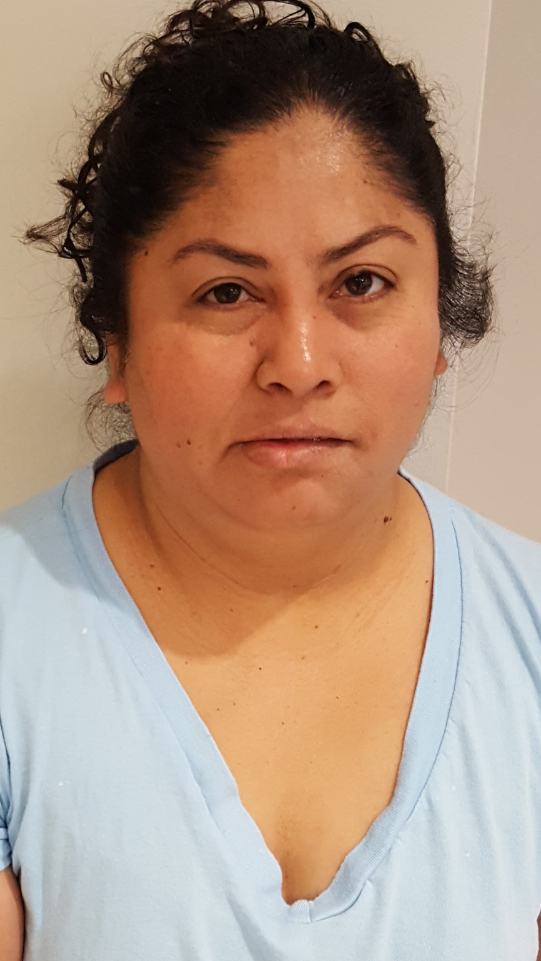

**Featured Staff Member-Ms. Mirna Rivas**

Ms. Mirna is a loving staff member, that not only helps keep our school nice and clean, but also is a vital part of our staff! Her love for the children is infectious! She enjoys spending time with our little ones, and always keeping a watchful eye on them. Ms. Mirna has been at Silverline since the beginning and we are so grateful to have her!

**A little about Montessori Education**

Montessori is designed to help all children reach their fullest potential at their own unique pace. A classroom whose children have varying abilities is a community in which everyone learns from one another and everyone contributes. Moreover, multiage grouping allows each child to find his or her own pace without feeling "ahead" or "behind" in relation to peers. Research studies show that Montessori children are well prepared for later life academically, socially, and emotionally. In addition to scoring well on standardized tests, Montessori children are ranked above average on such criteria as following directions, turning in work on time, listening attentively, using basic skills, showing responsibility, asking provocative questions, showing enthusiasm for learning, and adapting to new situations.

**April 2018**

**18434 Cypress North Houston Rd. 281-373-1200**

**FRIENDLY REMINDER**

In this section, remind families of anything new at your School (e.g., new annex, new playground equipment) or an on-going minor issue in your School (e.g., bringing sleeping bags back on Mondays).