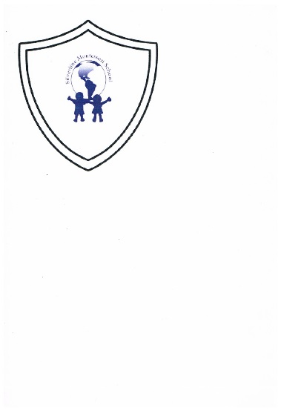 **Silverline Montessori** 

**December 2017 Snack Menu**

|  |  |  |  |  |
| --- | --- | --- | --- | --- |
| **Monday** | **Tuesday** | **Wednesday** | **Thursday** | **Friday** |
|  |  |  |  | **1**  **Morning Snack**  Hot Cinnamon Apples  Water  **Afternoon Snack**  Orange Segments  Ritz Crackers  Water  Image result for orange segments |
| **4**  **Morning Snack**  Wheat Tortillas, Refried Beans, Water  **Afternoon Snack**  Sun Butter Sandwich  Water  Image result for wheat tortilla | **5**  **Morning Snack**  Cottage Cheese  Diced Melon  Water  **Afternoon Snack**  Cucumber Slices  String Cheese  Water  Image result for cottage cheese | **6**  **Morning Sack**  Celery Stick, Sun Butter  **Afternoon Snack**  Goldfish Crackers, Banana Slices  Water  Image result for celery sticks | **7**  **Morning Snack**  Flavored Yogurt  Sliced Strawberries & Water  **Afternoon Snack**  Vegetable Slices  String Cheese  Water  Image result for string cheese | **8**  **Morning Snack**  Granola Bar, Milk & Water  **Afternoon Snack**  Wheats worth Crackers  Diced Melon & Water  Image result for wheatsworth crackers |
| **11**  **Morning Snack**  Pretzels, Sun butter & Water  **Afternoon Snack**  Cheez It’s & Water  Image result for cheese its | **12**  **Morning Snack**  Yogurt Dip, Sliced Carrots & Water  **Afternoon Snack**  Cottage Cheese, Fruit Slices & Water  Image result for carrot sticks | **13**  **Morning Snack**  Granola Bar, Fruit Juice  **Afternoon Snack**  Vegetable Slices, String Cheese, Water  Image result for granola bars | **14**  **Morning Snack**  Cottage Cheese Wheats worth Crackers, Water  **Afternoon Snack**  Apple Slices, Sun Butter Sandwich & Water  Image result for apple slices | **15**  **Morning Snack**  Wheat Roll or Bread, Chicken Salad  Water  **Afternoon Snack**  Puffed Cereal, Water or Milk  Image result for puffed cereal |
| **18**  **Morning Snack**  Pretzels, Cheese Slice  Water  **Afternoon Snack**  Fresh Vegetables, Yogurt Dip & Water  Image result for pretzels | **19**  **Morning Snack**  Flavored Yogurt, Blueberries & Water  **Afternoon Snack**  Cherry Tomatoes, Wheatsworth Crackers & Milk  Image result for yoplait yogurt | **20**  **Morning Snack**  Cheerios, sliced bananas & Milk  **Afternoon Snack**  Goldfish Crackers,  Fruit & Milk  Image result for goldfish crackers | **21**  **Morning Snack**  Cottage Cheese  Melon, & Water  **Afternoon Snack**  Cucumber Slices  String Cheese & Water  Image result for cottage cheese | **22**  Merry Christmas  Building Closed |

Continued on back

|  |  |  |  |  |
| --- | --- | --- | --- | --- |
| **Monday** | **Tuesday** | **Wednesday** | **Thursday** | **Friday** |
| **25**  Merry Christmas  Building Closed | **26**  Merry Christmas  Building Closed | **27**  **Morning Snack**  Rice Chex, Strawberries  Milk  **Afternoon Snack**  Hummus, Sliced Carrots & Water  Image result for hummus with carrots | **28**  **Morning Snack**  Apple Sauce, Goldfish & Water  **Afternoon Snack**  Grape Tomato,  Crackers & Milk  Image result for goldfish crackers  V: Vegetable Soup | **29**  **Morning Snack**  Pretzels, Cheese Sticks, & Water  **Afternoon Snack**  Celery Stick, Sun Butter & Water  Image result for celery sticks |