Silverline Montessori
May 2018 Breakfast and Lunch Menu

Monday | Tuesday | Wednesday | Thursday | Friday
 | 1 Breakfast  Corn Flakes, Mixed Fruit Cup, Milk  Lunch  Chicken Noodle Soup, Turkey & Cheese Roll Up  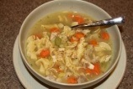  Fruit & Milk  V: Tomato Soup | 2 Breakfast  Whole Grain Waffle & Milk  Lunch  Lasagna  Strawberry Spinach Salad  Fruit Cup  Dinner Roll  Milk  V: Vegetarian Lasagna | 3 Breakfast  Wheat Toast with Peaches & Milk  Lunch  Taco w/Rice ,  Refried Beans,  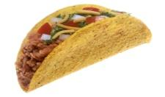  Salad,  Fruit & Milk  V: Veggie Taco | 4 Breakfast  Oatmeal, Slices of Strawberry, Water  Lunch  Chopped Beef Steak, Brown Gravy  Mashed Potatoes,  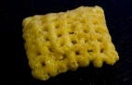  Green Bean & Milk  V: Tomato Soup
7 Breakfast  Waffle with Hot Cinnamon apples  Milk  Lunch  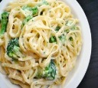  Pasta w/Alfredo Sauce, Chicken & Broccoli  Fruit & Milk  V: Fettuccine w/ Alfredo Sauce | 8 Breakfast  Orange Segments  Wheat English Muffins  Cream Cheese, Milk  Lunch  Chicken Quesadilas  Spanish Rice ,Tossed Salad, Peaches & Milk  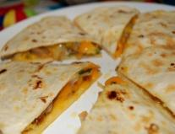  V: Cheese Quesadillas | 9 Breakfast  Pineapple Chunks , French Toast, Milk  Lunch  Baked Chicken  Fiesta Corn  Wheat Roll or Bread  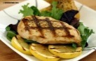  Apple Slices  Milk  V: Veggie Nuggets | 10 Breakfast  Peach Dices  Wheat Toast, Milk  Lunch  Chili w/ Beans  Rice  Strawberry Spinach Salad  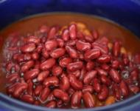  Fruit Cup  Milk  V: Veggie Chili | 11 Breakfast  Oatmeal , Strawberry Slices, Water  Lunch  Fish Sticks  Mac N Cheese  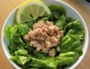  Fruit Cup  Milk  V:Mac N Cheese
14 Breakfast  Tropical Fruit, Corn Flakes, Milk  Lunch  Chicken and Rice, Peas & Carrots,  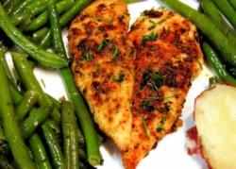  Pineapple Tidbits  Milk  V: Veggie Burgers | 15 Breakfast  Orange Segments, English Muffins w/cream cheese. Water  Lunch  Chicken Nuggets,  Mac N Cheese,  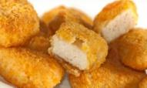  Veggies, Fruit  Milk  V: Veggie Nuggets | 16 Breakfast  Croissant with Cream Cheese & Fruit  Lunch  Spaghetti w/Meat Sauce,  Vegetables  Fruit & Milk  V: Spaghetti with Marinara | 17 Breakfast  Pancakes  Peaches  Milk  Lunch  Taco w/Rice , Refried Beans,  Salad, Fruit & Milk  V: Veggie Taco | 18 Breakfast  Oatmeal, Slices of Strawberry, Water  Lunch  Turkey Sandwich  Lettuce, Tomatoes, Pickles, Potato Chips  Fruit & Milk  V: Veggie Burger
21 Breakfast  Waffle with Hot Cinnamon apples  Milk  Lunch  Hot Dogs  Fritos  Strawberry Spinach Salad  Fruit  Milk  V: Veggie Chili | 22 Breakfast  Peach Dices  Wheat Toast, Milk  Lunch  Lasagna  Strawberry Spinach Salad  Fruit Cup  Dinner Roll  Milk  V: Vegetarian Lasagna | 23 Breakfast  Cheerios & Banana Slices  Lunch  Baked Chicken & Couscous,  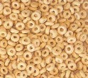  Salad  Fruit & Milk  V: Veggie Nuggets | 24 Breakfast  English Muffin with Cream Cheese and peaches  Lunch  Fish Sticks,  Mac N Cheese,  Vegetables, Fruit & Milk  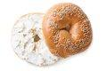  V: Mac N Cheese | 25 Breakfast  Peaches Slices with Corn Flakes. Water  Lunch  Cheese Pizza,  Garden Salad  Fruit & Milk  V: same
28  Building Closed in Observance of Memorial Day | 29 Breakfast  French Toast & Milk  Lunch  Chicken Nuggets  Vegetables  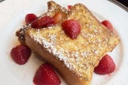  Fruit Salad & Milk  V:Veggie Nuggets | 30 Breakfast  Croissant with Cream Cheese & Fruit  Lunch  Spaghetti w/Meat Sauce,  Vegetables  Fruit & Milk  V: Spaghetti Marinara Sauce | 31 Breakfast  Wheat Toast with Peaches & Milk  Lunch  Taco w/Rice ,  Refried Beans,  Salad,  Fruit & Milk  V: Veggie Taco

